**Website Snapshots**

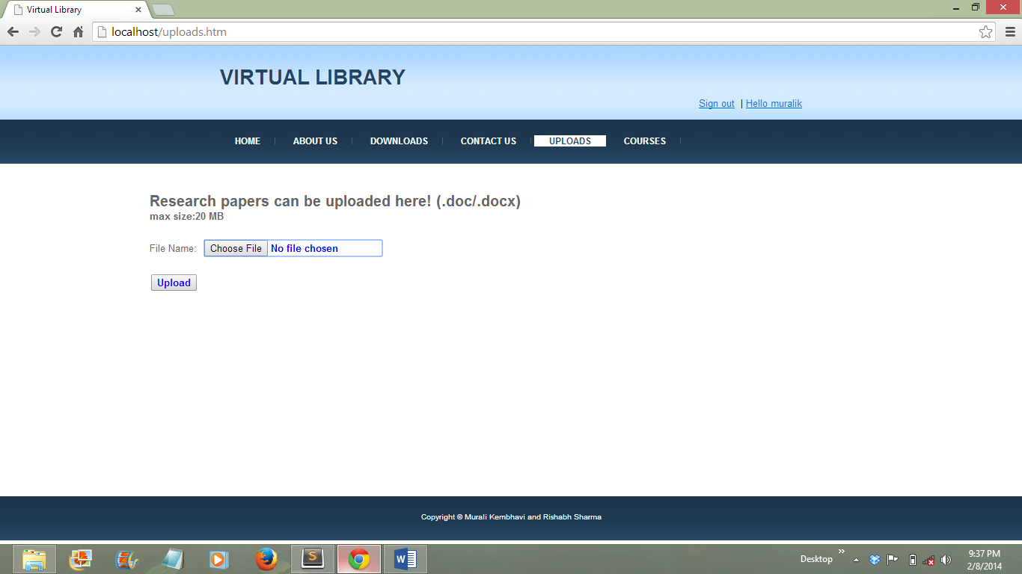

**Upload page for students**

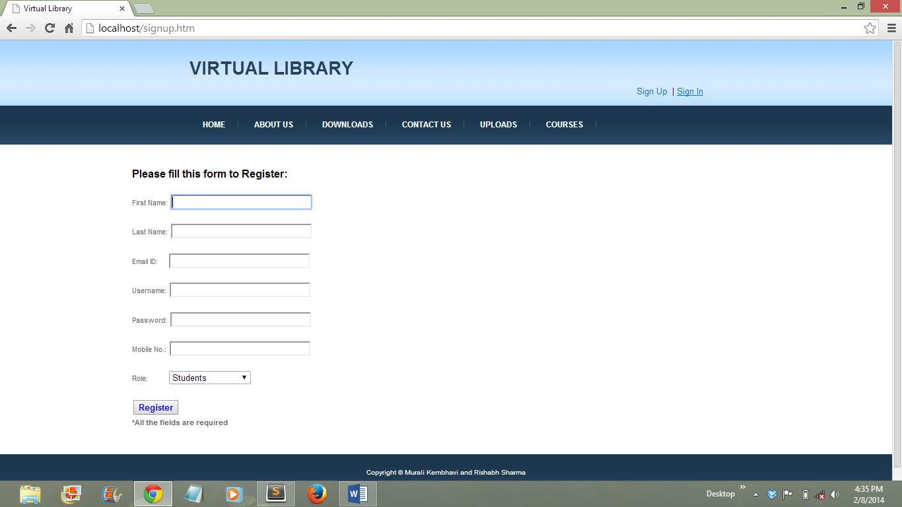

**Sign Up page for students, author and content manager**

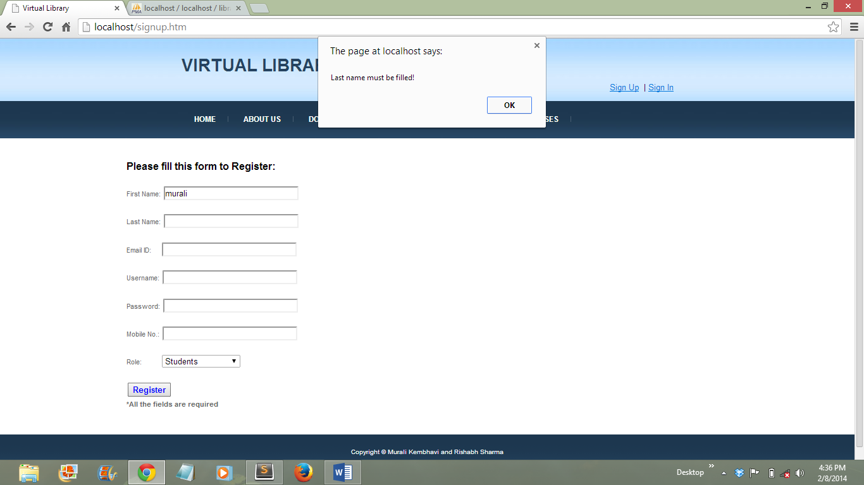

**Sign up form validation**

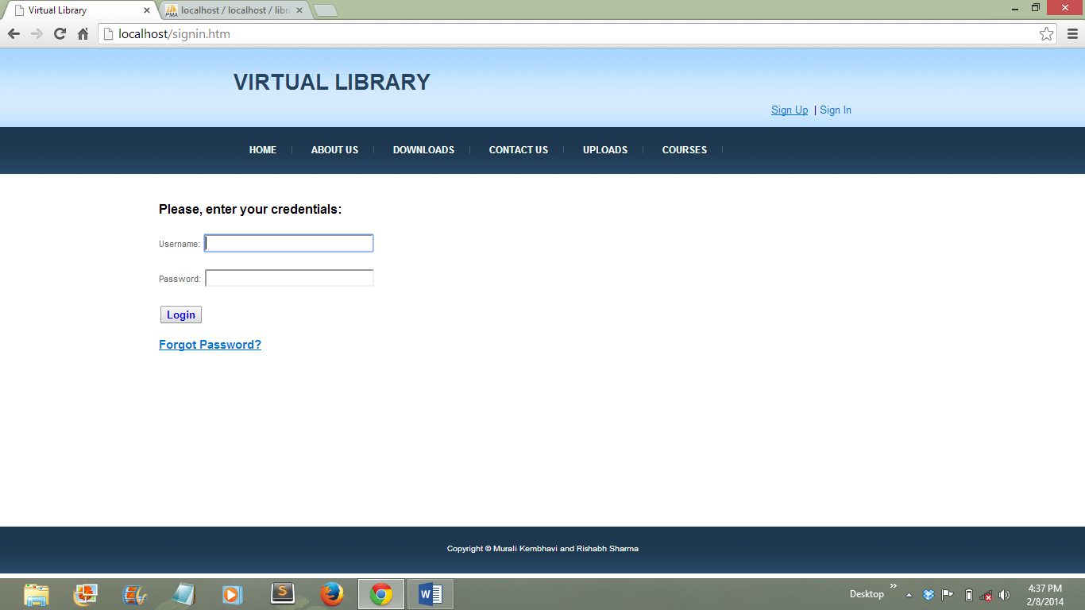  
**Sign in page for students**

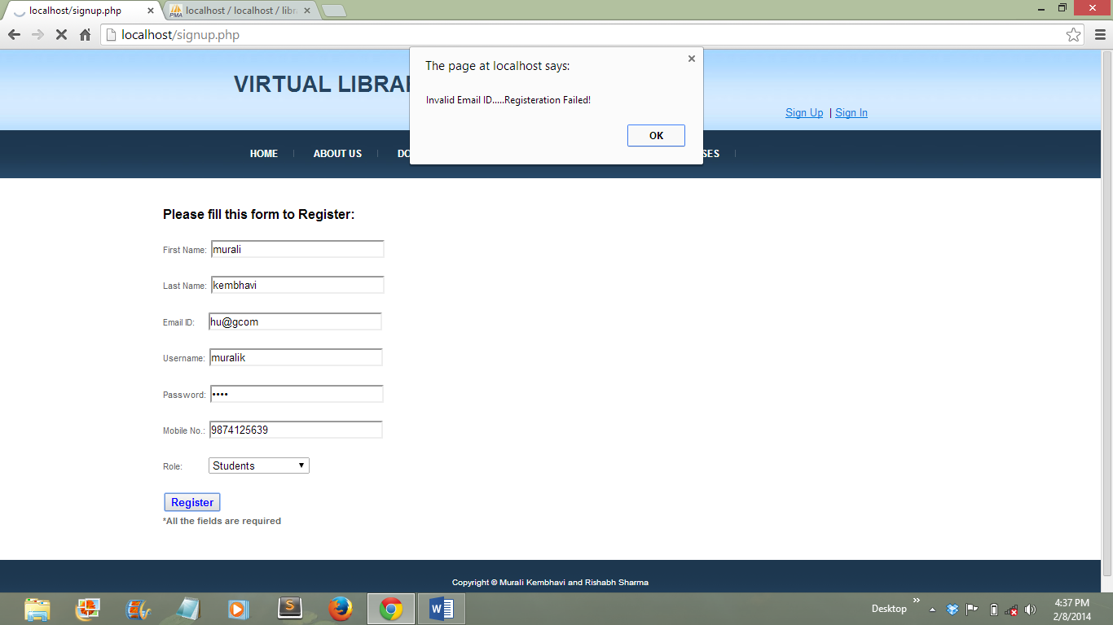

**Sign up form validation**

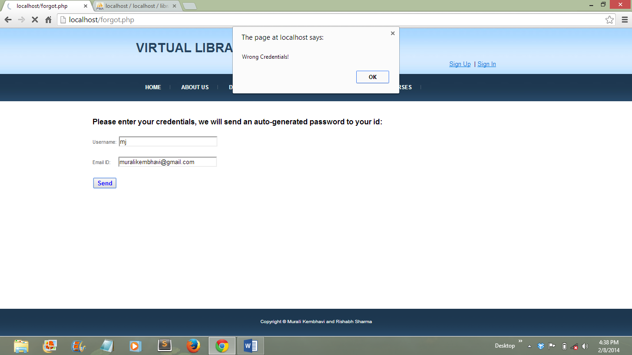

**Forgot password form validation**

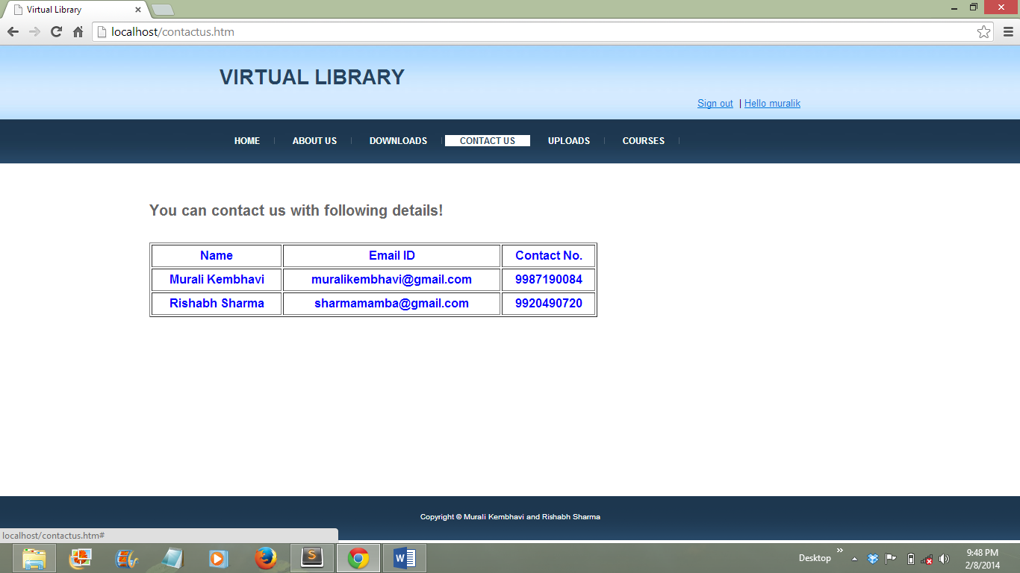

**Contact us page**

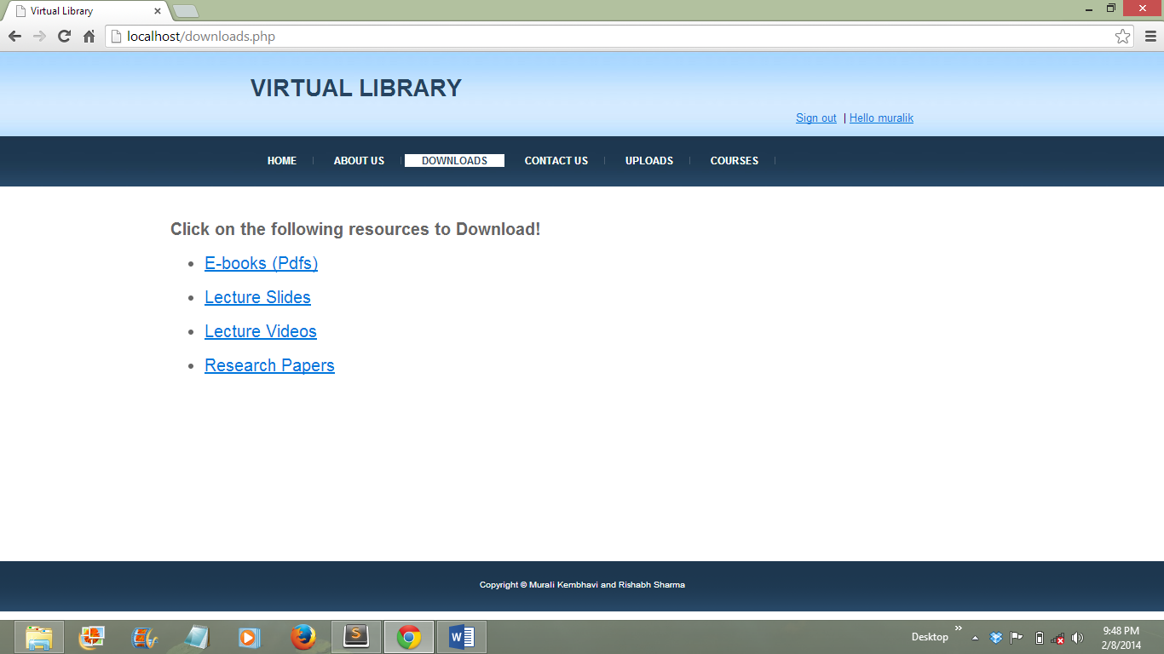

**Downloads page for students**

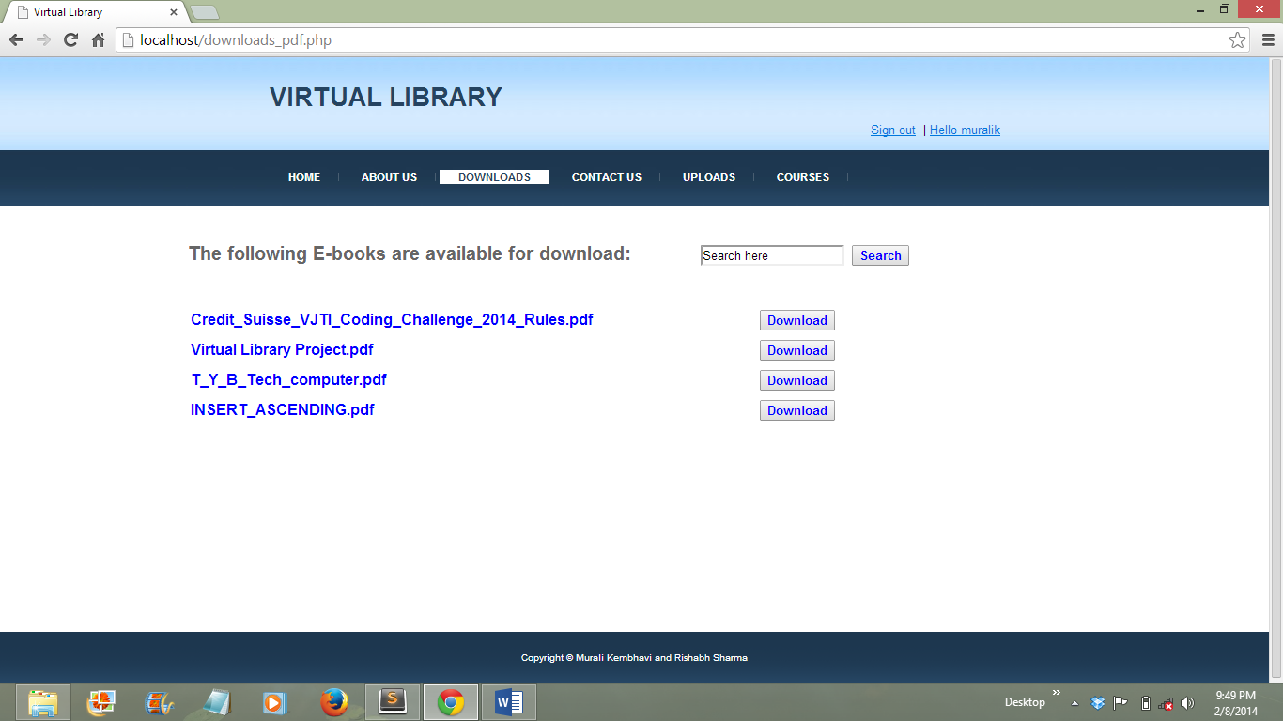

**E-books download page for students**

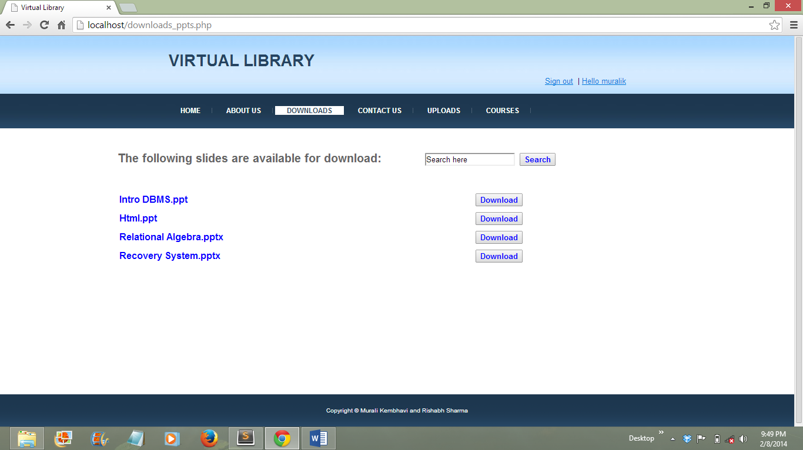

**Lecture slides downloads page for students**

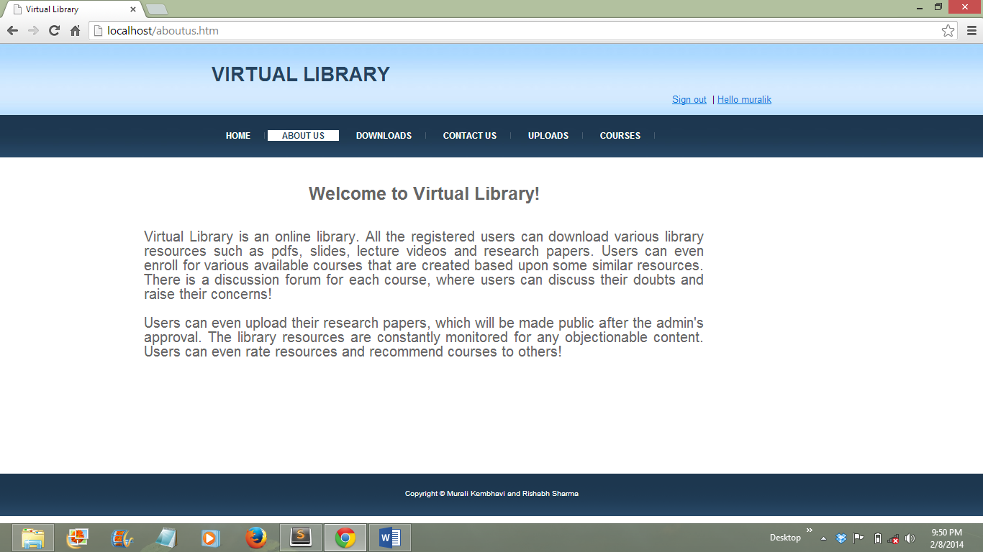

**About us page**

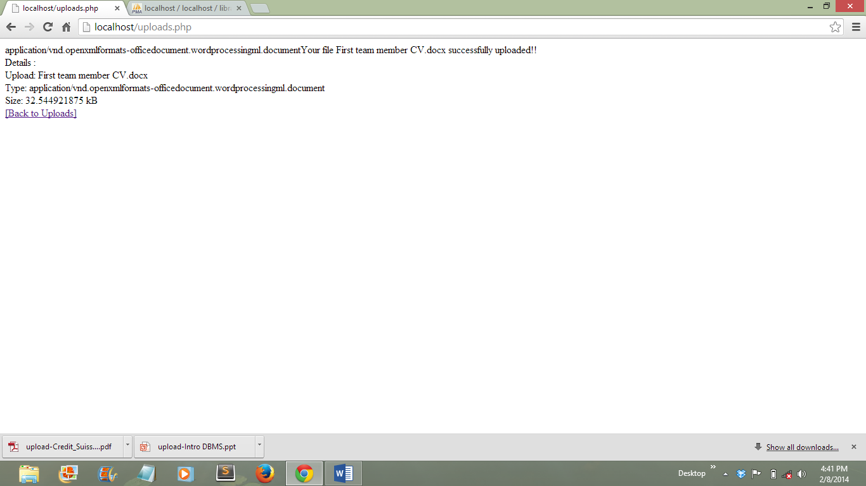

**Confirmation of uploads page for students**

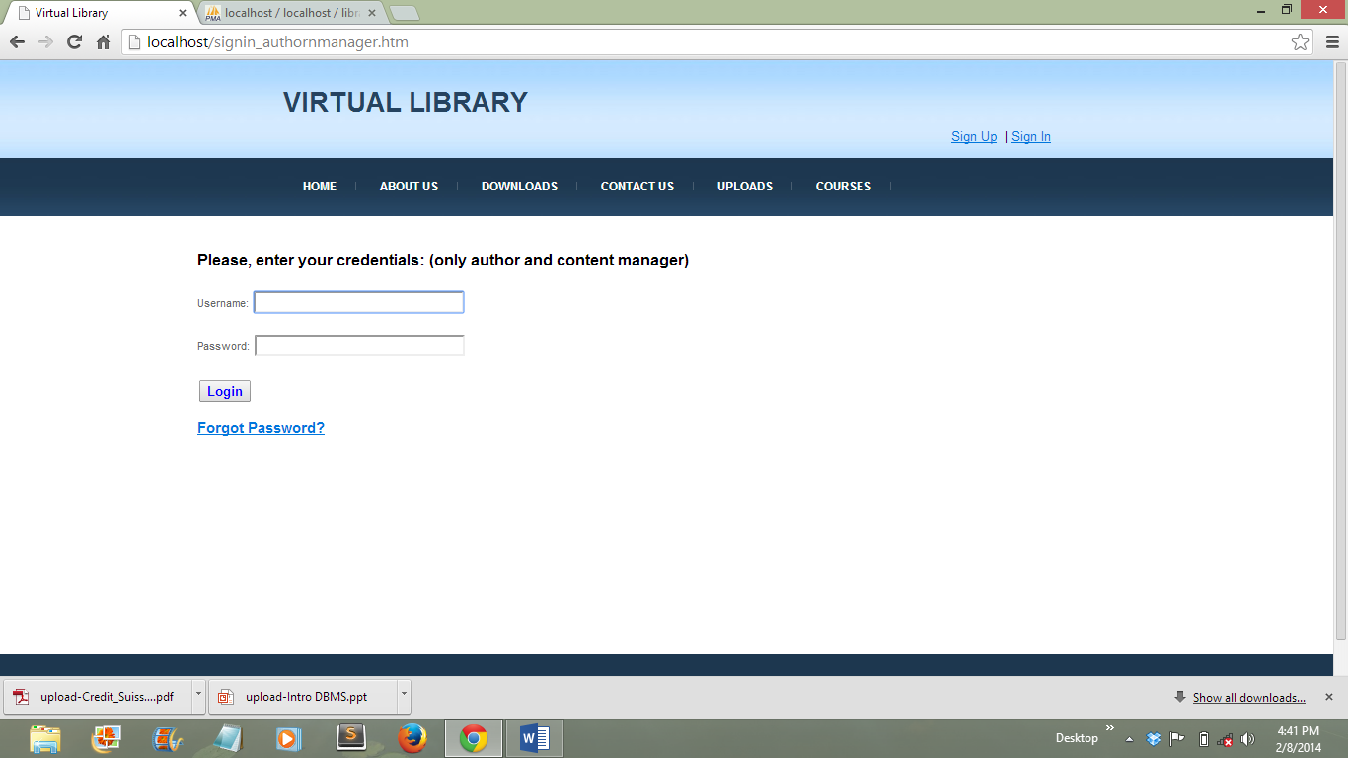

**Sign in page for author and content manager**

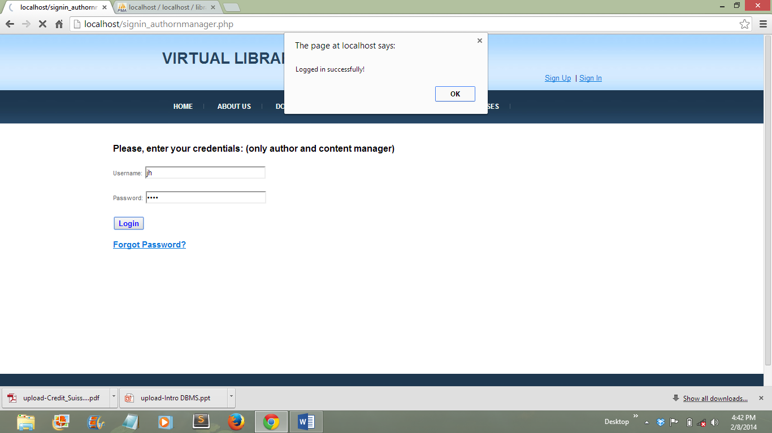

**Author and manager sign in page validation**

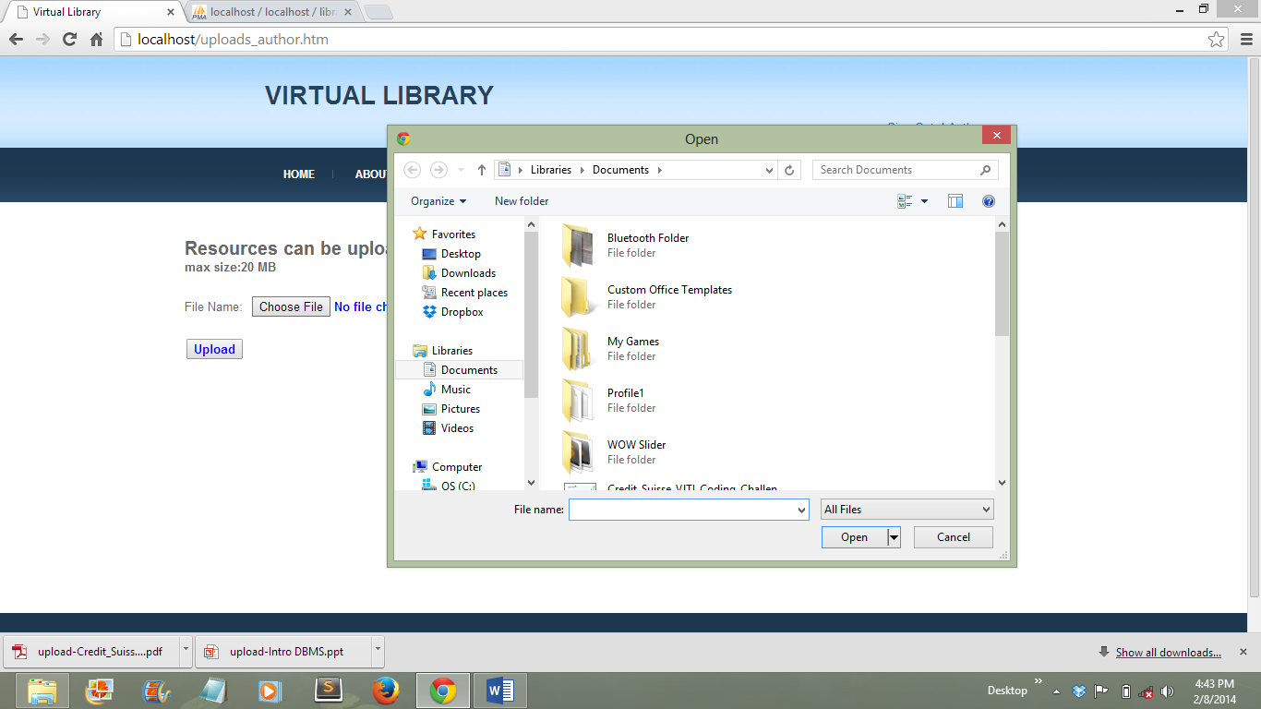

**Author and manager uploads page**

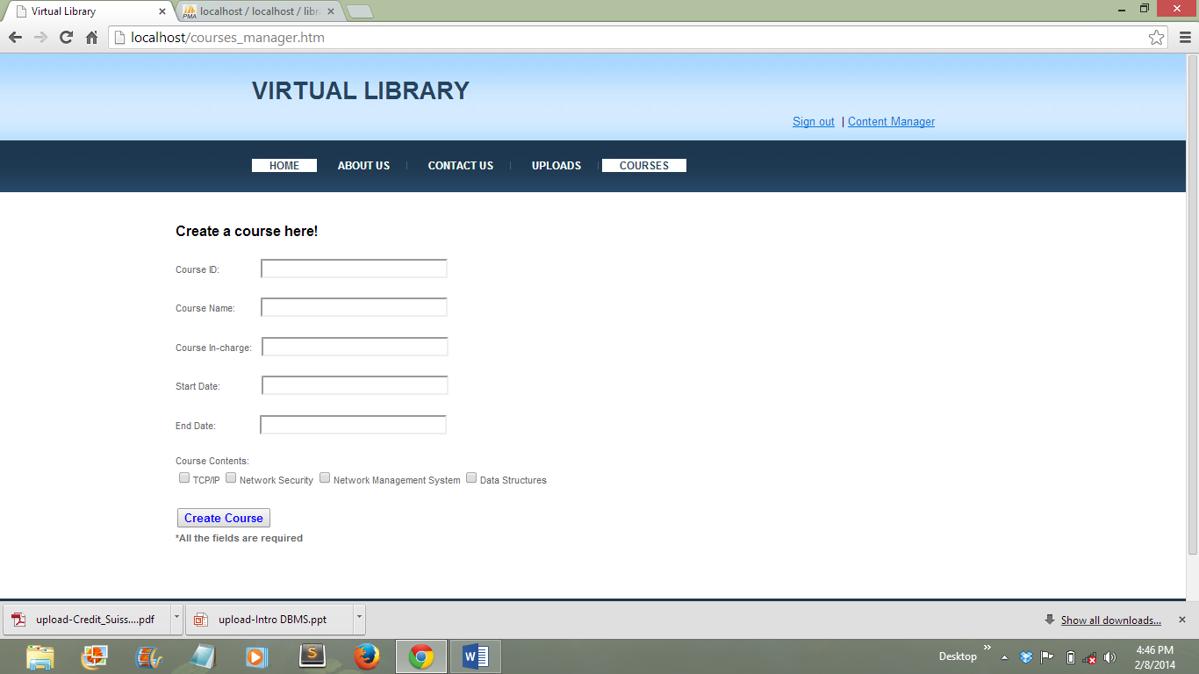

**Create course page for content manager**

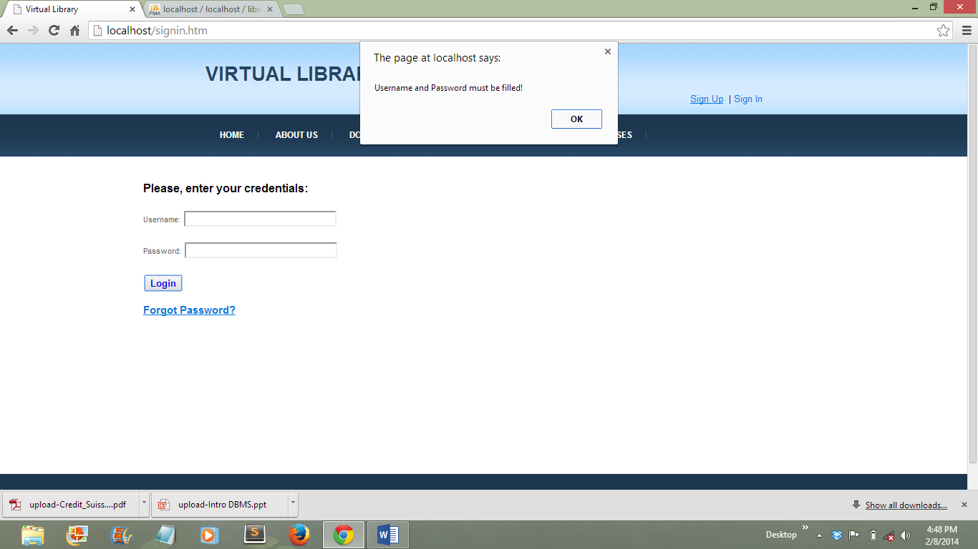

**Sign in form validation for students**

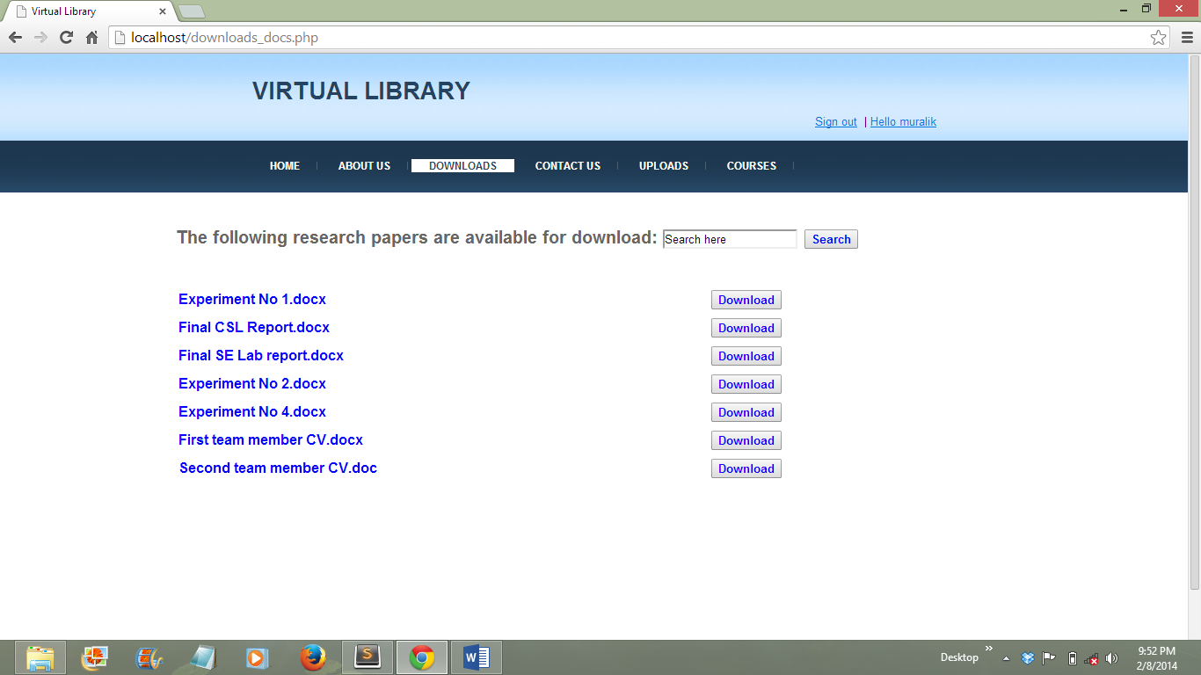

**Research papers downloads page for students**

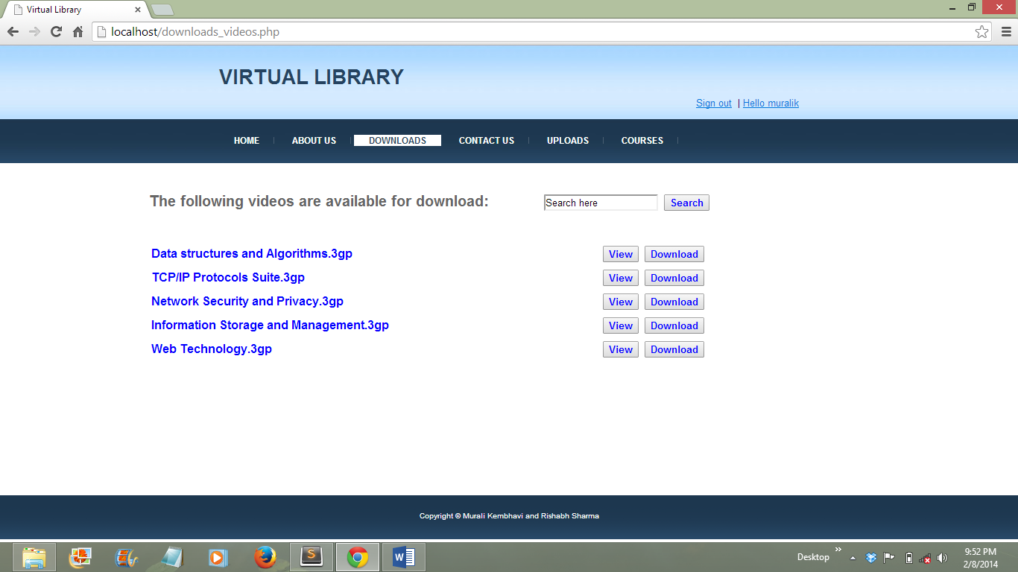

**Lecture videos downloads page for students**

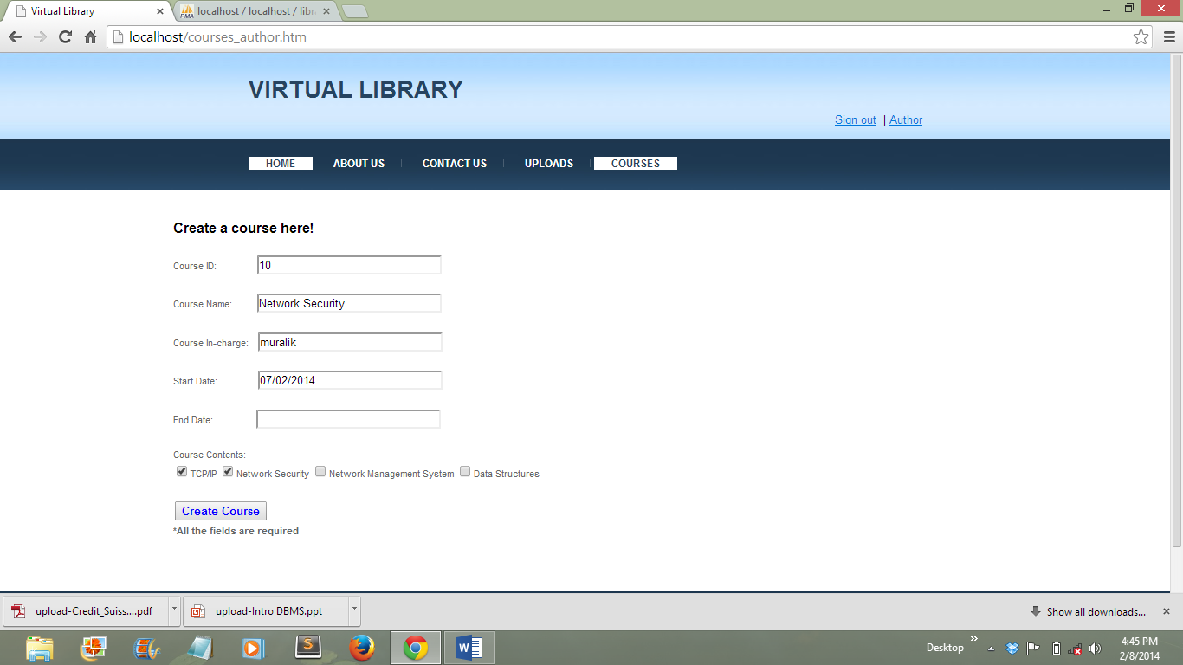

**Create course page for content manager**

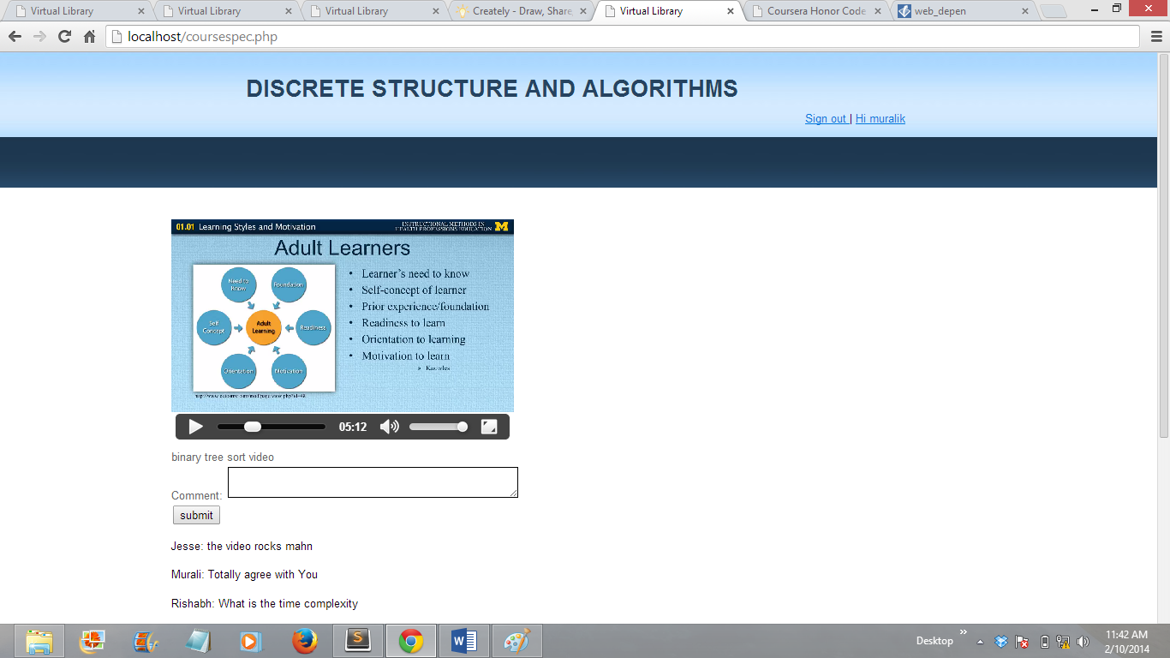

**Courses view page for students**

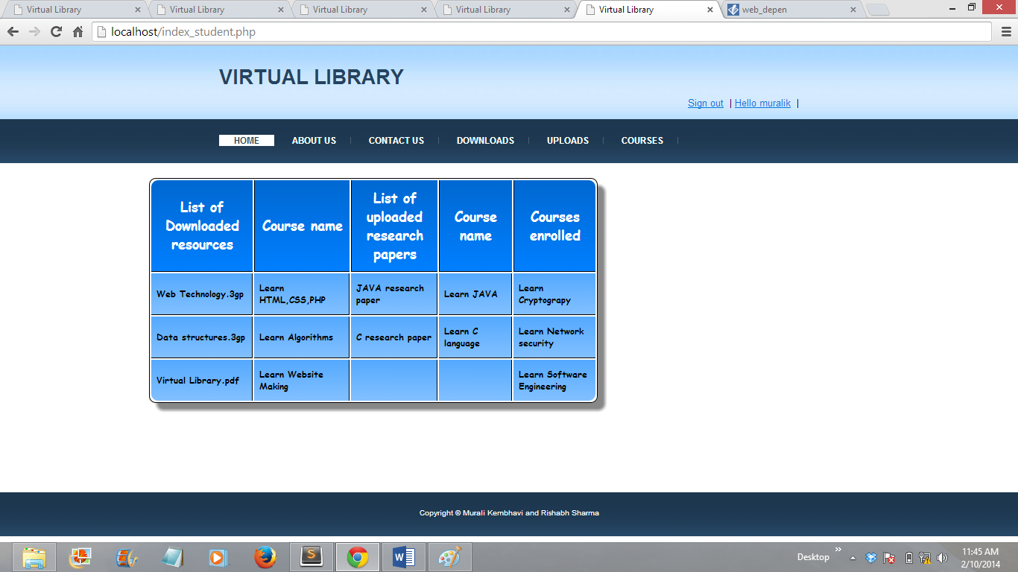

**Student home page**

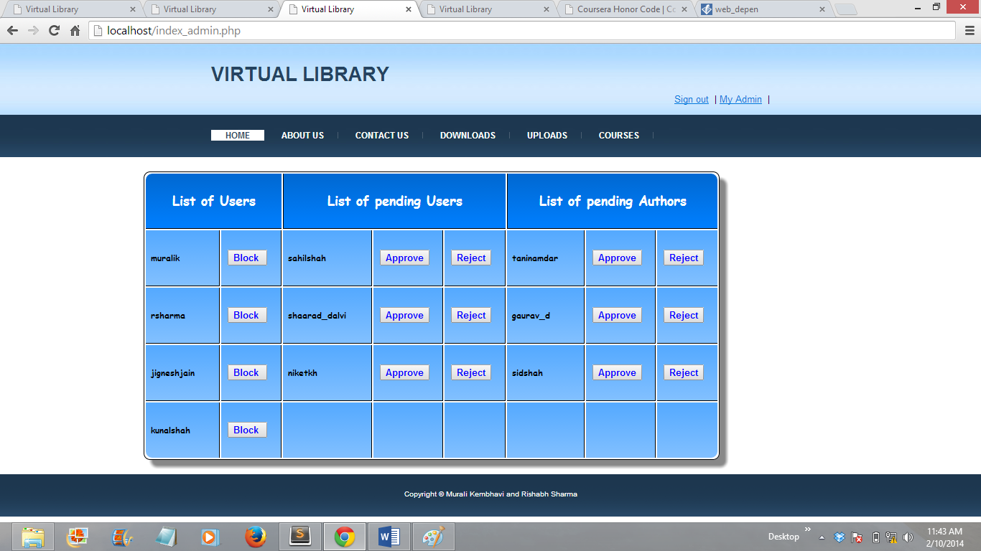

**Admin home page**

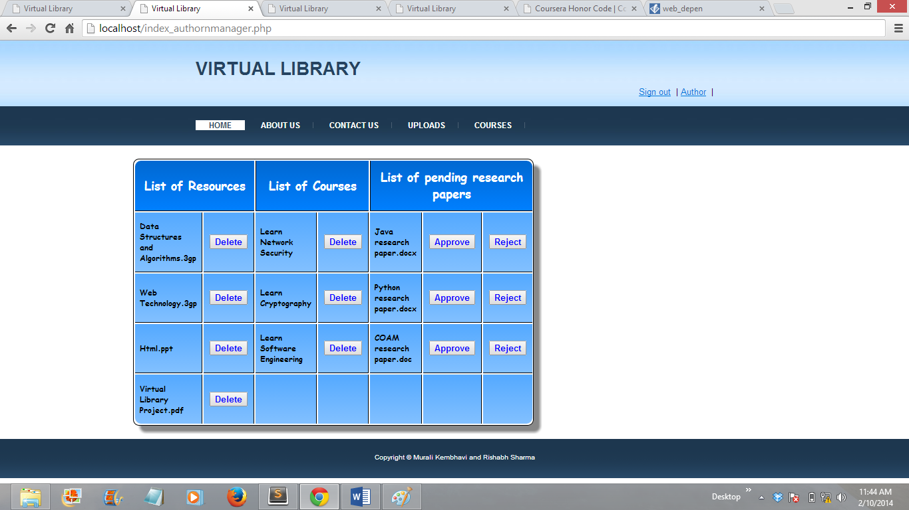

**Author/content manager home page**

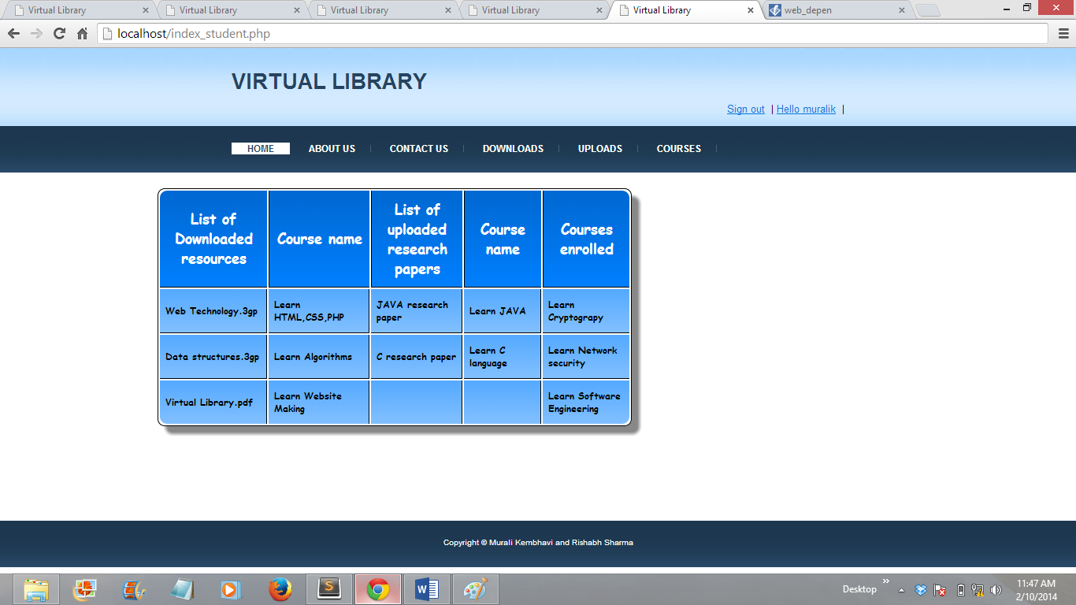

**Courses view page**

**Relation between web-pages**

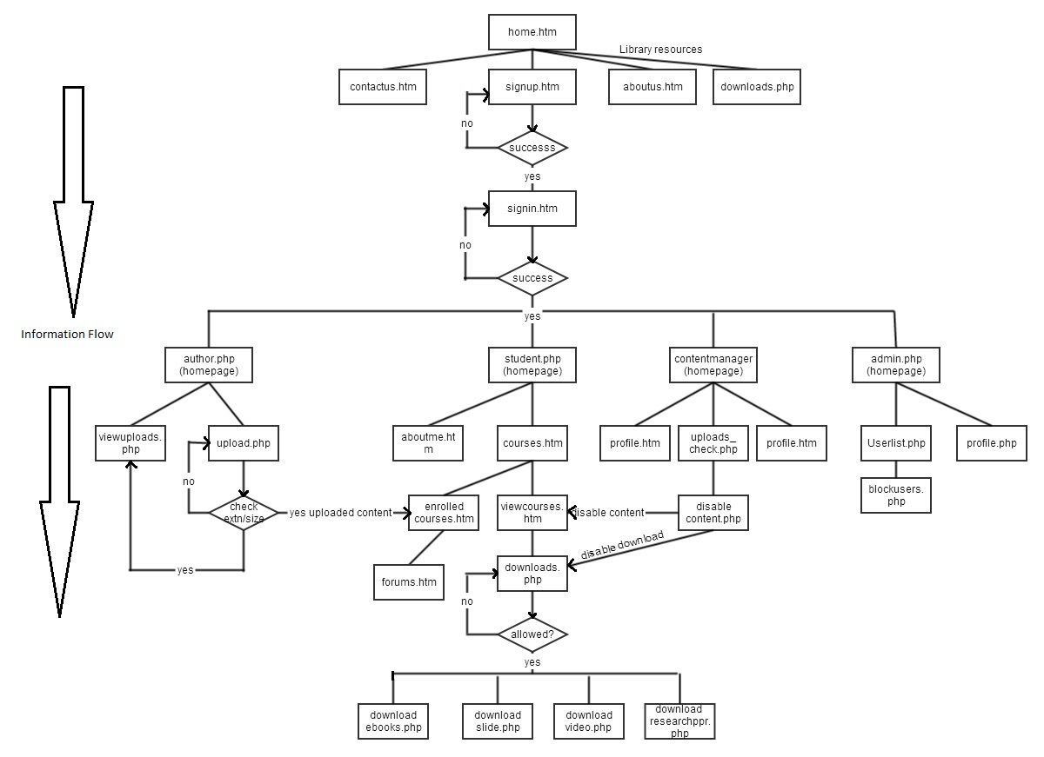

**Database Schema**

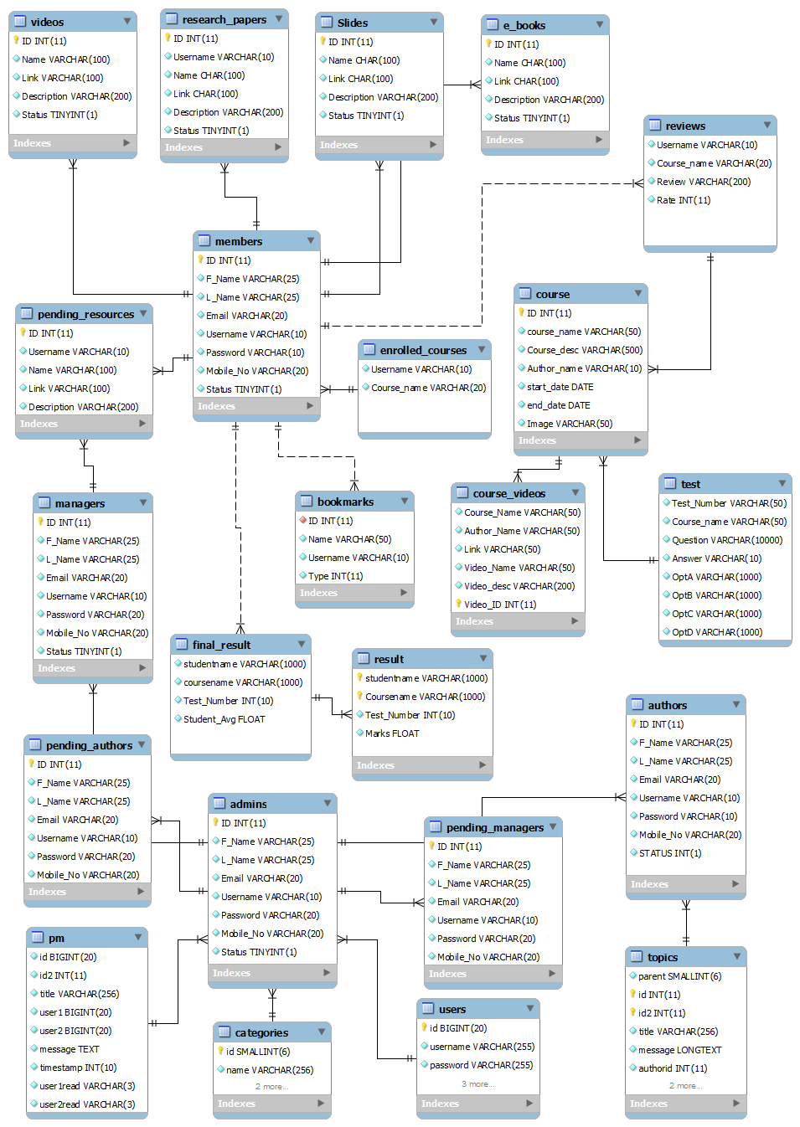

**Functionalities covered till date**

* Sign up and sign in form validation
* Account verification by sending E-mail to the user
* Forgot password for students and author/manager
* Registered students can download library resources
* Registered students can upload research papers
* Approval of research papers by content manager before making public
* Registered students can enroll for library courses
* Unregistered students can only view permitted library resources
* Registered students cannot copy library resources’ contents
* Enrolled students can use discussion forums
* Author/content manager can upload/delete library resources
* Author/content manager can create/delete courses
* Admin can add/block users
* Admin can add/block authors and content managers
* Admin can manage discussion forums